Biological Disturbance Agent Testing
BDA v1.0 for LANDIS-II
Tests performed by Nicholas G. Hayden, UW-Madison

Ecoregion map used for all tests
(1 pixel = 100 m)
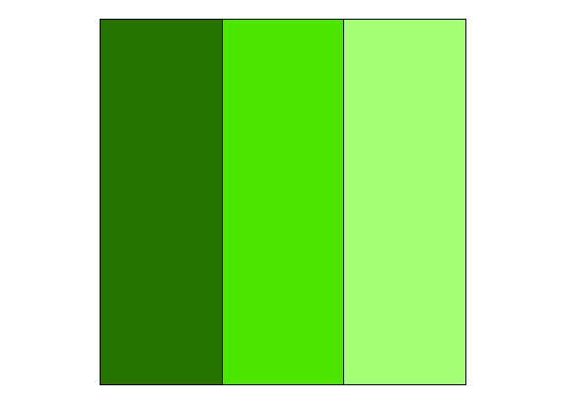
Site Resource Dominance: Left = 1.0 Center = 0.66 Right = 0.44
Outbreak Probability: Left = 0.66 Center = 0.44 Right = 0.29
ROS = 2

Tests 1 through 26 – Dispersal Inputs

Default Values

Dispersal = Yes
DispersalRate = 100
EpidemicThresh = .3
InitialEpicenterNum = 10
OutbreakEpicenterCoeff = .5
SeedEpicenter = Yes
SeedEpicenterCoeff = 2
DispersalTemplate = 4N

Test 1 – Epicenter # equals 10
(red = outbreak zone)
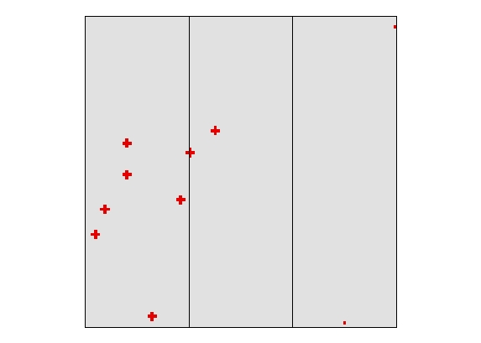
Result: test worked – 10 outbreaks occurred. Note: single pixel represents outbreak that did not spread due to outbreak probability lower than Epidemic Threshold (0.3).

Test 2 – Epicenter # equals 1
(red = outbreak zone)
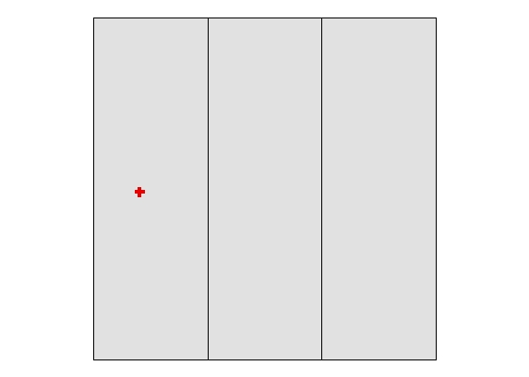
Result: test worked – 1 outbreak occurred
Test 3 – Epicenter # equals 0
(red = outbreak zone)

Result: test worked – no outbreak zones

Test 4 – Dispersal equals Yes
(red = outbreak zone)
Result: test worked – 10 outbreaks occurred

Test 5 – Dispersal equals No
(red = outbreak zone)
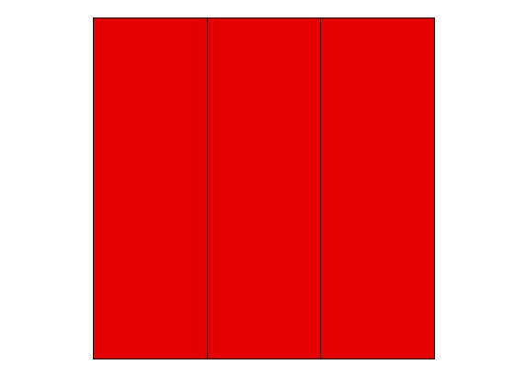
Result: test worked – outbreak occurred everywhere

Test 6 – Dispersal rate equals 50 meters
(red = outbreak zones)
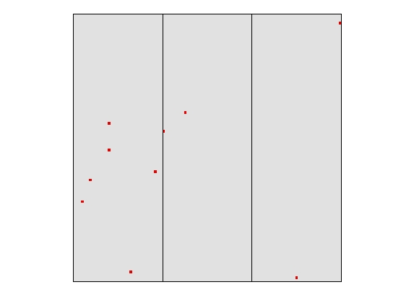
Result: test worked – outbreak zones are < 100 m wide

Test 7 – Dispersal rate equals 100
(red = outbreak zone)
Result: test worked – outbreak zones are up to 300 m wide

Test 8 – Dispersal rate equals 500
(red = outbreak zone)
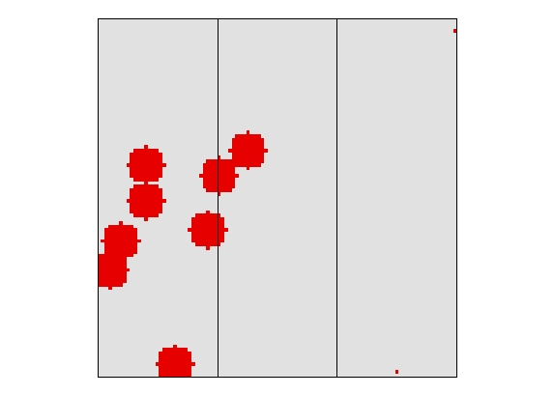
Result: test worked – outbreak zones up to 1100 m wide

Note: For tests 9 through 13, DispersalRate = 500

Test 9 – Dispersal template equals 4N
(red = outbreak zone)
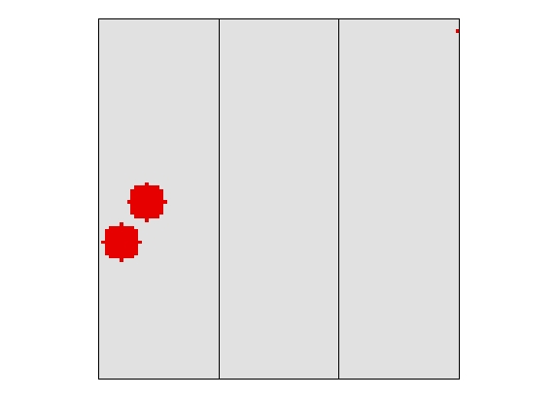
Result: test worked – outbreak zones followed 4N dispersal

Test 10 – Dispersal template equals 8N
(red = outbreak zone)
Result: test worked – outbreak zones followed 8N dispersal
Test 11 – Dispersal template equals 12N
(red = outbreak zone)
Result: test worked – outbreak zones followed 12N dispersal

Test 12 – Dispersal template equals 24N
(red = outbreak zone)
Result: test worked – outbreak zones followed 24N dispersal

Test 13 – Dispersal template equals MaxRadius
(red = outbreak zone)
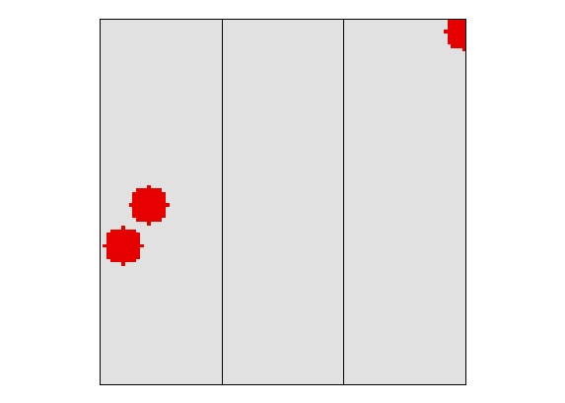
Result: test worked – outbreak zones followed MaxRadius dispersal

Note: For tests 14 through 26, DispersalRate = 200

Test 14 – Seed Epicenter equals yes
Timestep1 – Outbreak zones
(red = current outbreak zone, orange = prior year’s outbreak zone)
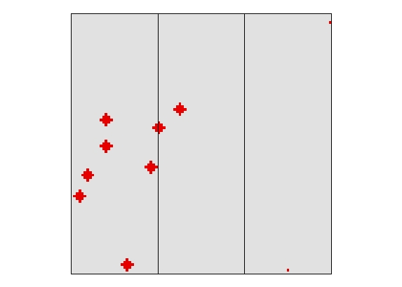
Test 14 (cont.)

Timestep1 – Severity
(red = 3, orange = 2)
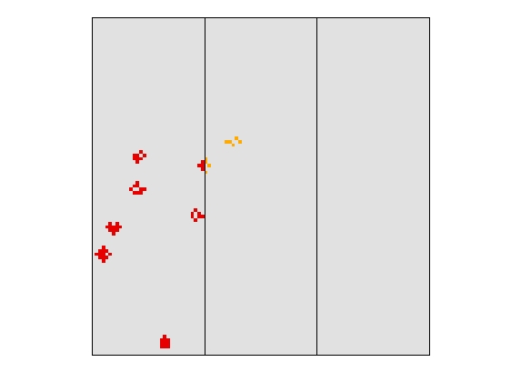

Timestep2 – Outbreak zones
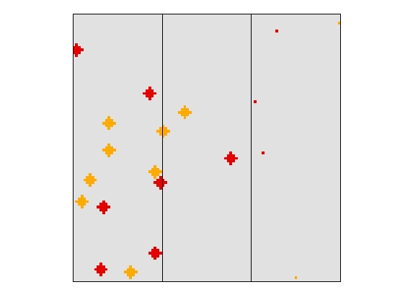

Test 14 (cont.)

Timestep2 – Severity (3 = red, 2 = orange)
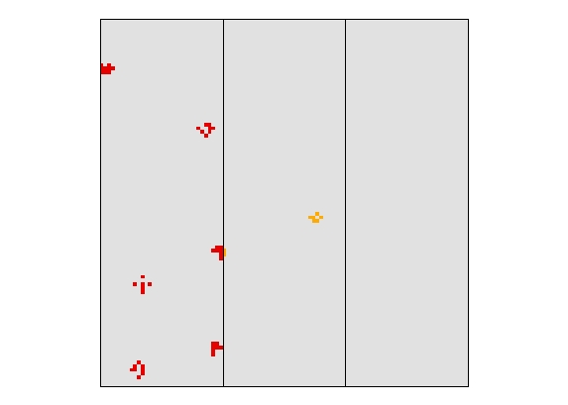

Timestep3 – Outbreak zones
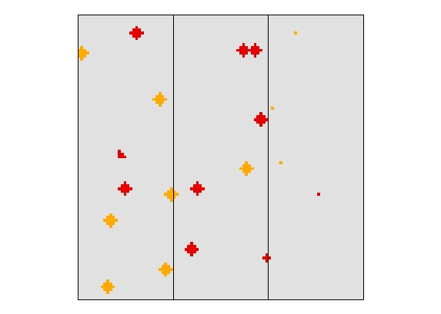

Test 14 (cont.)

Timestep3 – Severity
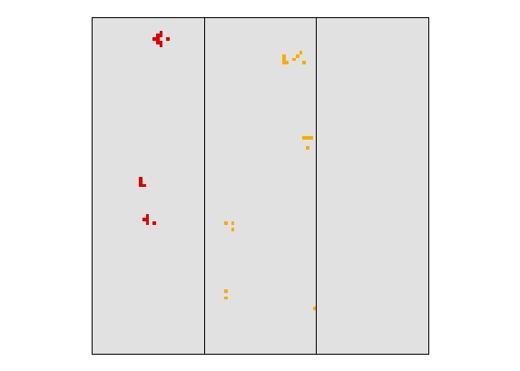
Results: test worked – new outbreak zones occurred outside of old outbreak zones, severity was driven by ecoregion, and severely disturbed pixels did not host outbreaks multiple times.

Note: For test 15, OutbreakEpicenterCoeff = 0.01

Test 15 – Seed Epicenter equals no

Timestep1 – Outbreak zones
(red = current outbreak zone, orange = last year’s outbreak zone)

Timestep1 – Severity
(red = 3, orange = 2)
Test 15 (cont.)

Timestep2 – Outbreak zones
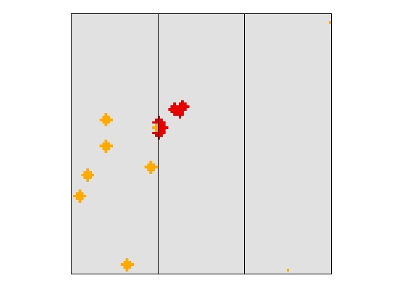

Timestep2 – Severity
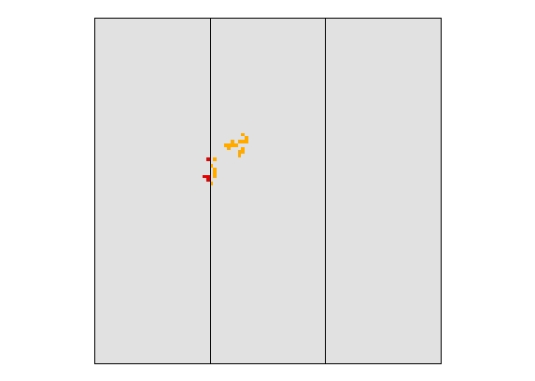

Test 15 (cont.)

Timestep3 – Outbreak zones
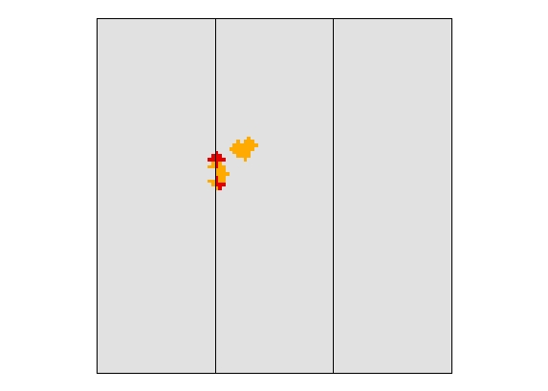

Timestep3 – Severity
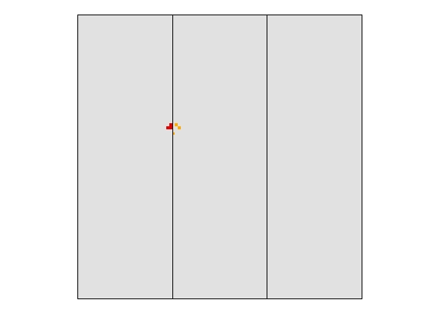
Result: test worked – new outbreak zones only occurred inside of old outbreak zones, severity was varied by ecoregion, and severely disturbed pixels did not host outbreaks multiple times.

Test 16 – Actual Outbreak percentage vs. Expected (InitialEpicenterNum = 1,000)

Outbreak Zones (red = outbreak zone)
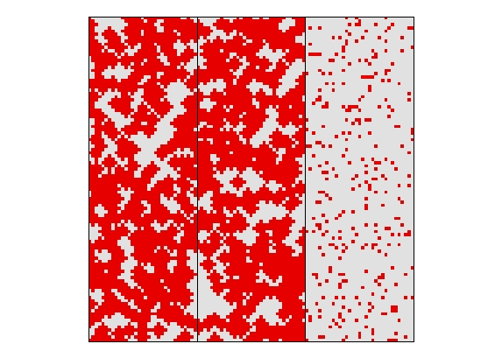

Actual Outbreak (red = outbreak)
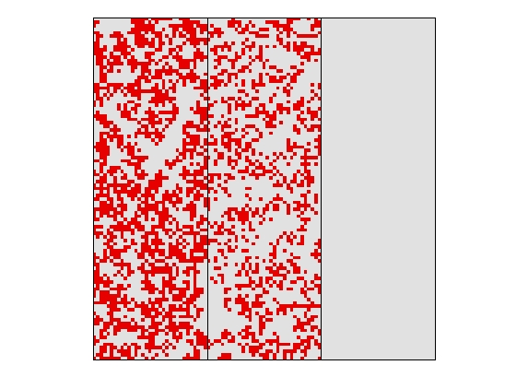
Results: the percentage of possible outbreak zones where actual outbreaks occur: 0.675 for zone 1; 0 .446 for zone 2; 0.0 for zone 3 (Epidemic Threshold is 0.3 and the vulnerability for zone 3 is 0.29) is as expected based on the initial vulnerability values.

Note: For tests 17 through 26, EpidemicThresh = 0, and InitialEpicenterNum = 30
Note: For tests 17 through 19, SeedEpicenter = No

Test 17 – Outbreak Epicenter Coefficient equals 0.001
Severity at Time 1 (Red = 3, orange = 2)
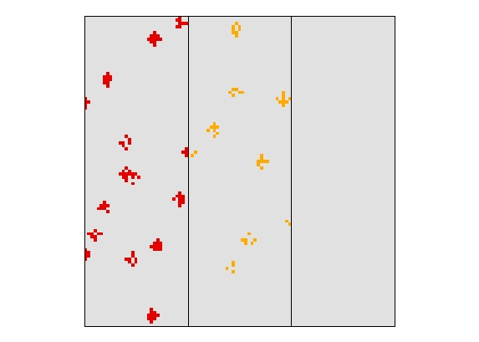
Outbreak zones at Time 2 (red = new outbreak, orange = old outbreak)
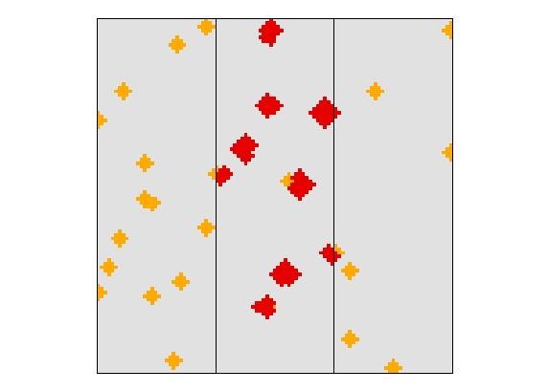
Results: 51 new epicenters were created from the 53 potential epicenter sites (severity = 2 in Time 1), as expected given a very small epicenter coefficient.

Test 18 – Outbreak Epicenter Coefficient equals 0.01
Severity at Time 1 (Red = 3, orange = 2)
Outbreak zones at Time 2 (red = new outbreak, orange = old outbreak)
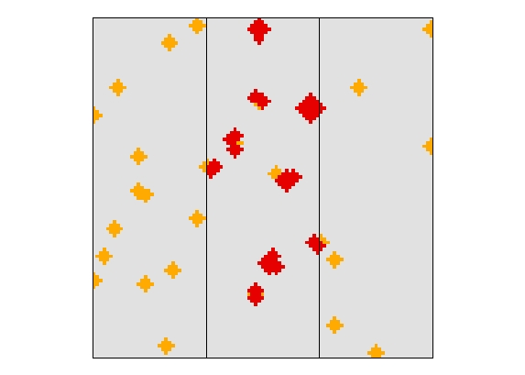
Results: 39 new epicenters were created from the 53 potential epicenter sites (severity = 2 in Time 1), as expected given a slightly higher epicenter coefficient.

Test 19 – Outbreak Epicenter Coefficient equals 0.1
Severity at Time 1 (Red = 3, orange = 2)
Outbreak zones at Time 2 (red = new outbreak, orange = old outbreak)
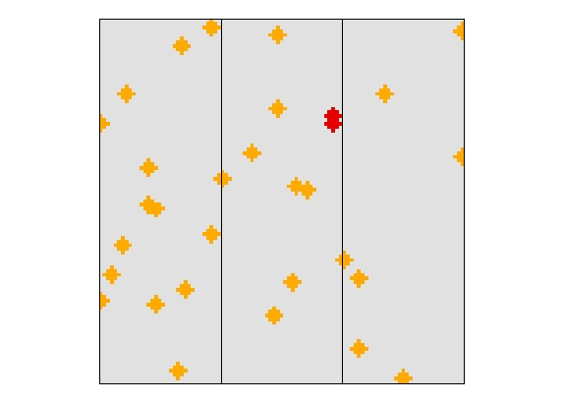
Results: 2 new epicenters were created from the 53 potential epicenter sites (severity = 2 in Time 1), as expected given a higher epicenter coefficient

Test 20 – Outbreak Epicenter Coefficient equals 0.2
Severity at Time 1 (Red = 3, orange = 2)
Outbreak zones at Time 2 (red = new outbreak, orange = old outbreak)
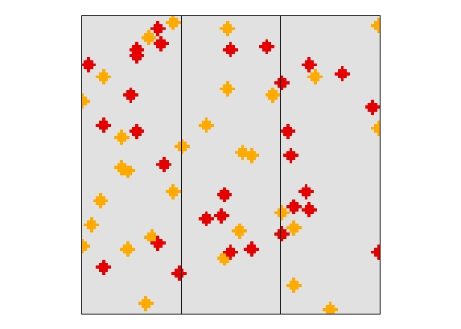
Results: 0 new epicenters were created from the 53 potential epicenter sites (severity = 2 in Time 1), as expected given a high epicenter coefficient; the program then defaults to seed dispersal, creating 30 new epicenter sites randomly across the landscape

Test 21 – 26 – Seed Epicenter Coefficient

Seed Epi. Coeff. | # Epi. TimeStep 1 | # Epi. TimeStep 2 | # Epi. TimeStep 3
0.01 | 30 | 40 | 40
0.05 | 30 | 17 | 18
0.1 | 30 | 11 | 12
0.2 | 30 | 5 | 9
0.3 | 30 | 1 | 8
0.5 | 30 | 30 | 30

Results: As expected, the number of new epicenters created by seed dispersal is inversely related to the seed epicenter coefficient; as the coefficient values increase, fewer new epicenters are created, until no new epicenters are created by seeding and the program defaults to the initial epicenter number (30).

Tests 27 through 38 – Neighborhood Resource Inputs

Default Values

Dispersal = Yes
DispersalRate = 200
EpidemicThresh = 0
InitialEpicenterNum = 30
OutbreakEpicenterCoeff = 0.01
SeedEpicenter = No
SeedEpicenterCoeff = 0.1
DispersalTemplate = 4N

NeighborFlag = Yes
NeighborSpeedUp = None
NeighborRadius = varies with each test
NeighborShape = Uniform
NeighborWeight = 1

Test 27 – NeighborRadius equals 100 m

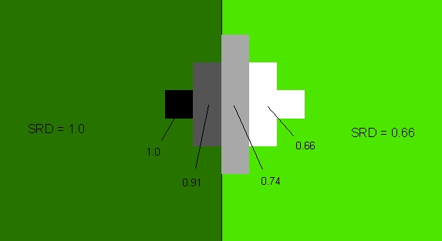

Result: Neighborhood Resource Dominance (NRD) is equal to the average Site Resource Dominance (SRD) of the 4 nearest neighbors

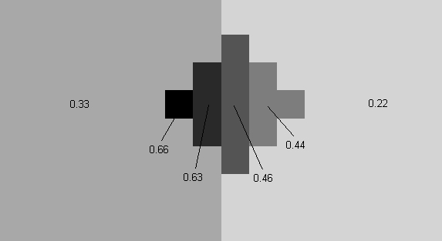

Result: Site Vulnerability (SV) is equal to (SRD + (NRD*NW)) / (1 + NW) * ROS/3; in this case ROS (regional outbreak status) = 2 and NW (NeighborWeight) = 1

Test 28 – NeighborRadius equals 200 m

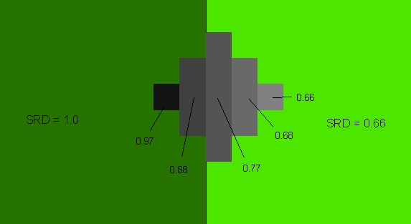

Result: Neighborhood Resource Dominance (NRD) is equal to the average Site Resource Dominance (SRD) of the 12 nearest neighbors.

Test 29 – NeighborRadius equals 500 m

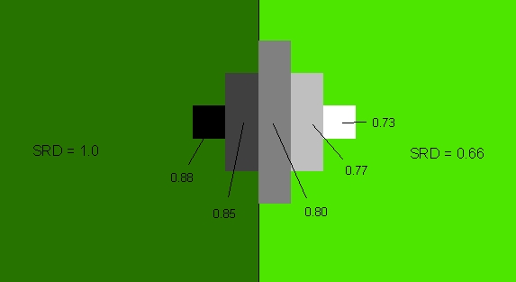

Result: Neighborhood Resource Dominance (NRD) is equal to the average Site Resource Dominance (SRD) of the 80 nearest neighbors.

Test 30 – NeighborShape equals linear (NeighborRadius = 220)

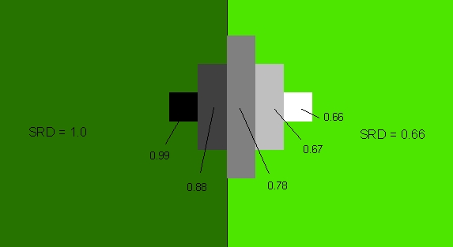

Result: Neighborhood Resource Dominance (NRD) is equal to the weighted (by distance from cell) average Site Resource Dominance (SRD) of the 12 nearest neighbors.

Test 31 – NeighborShape equals gaussian (NeighborRadius = 250)

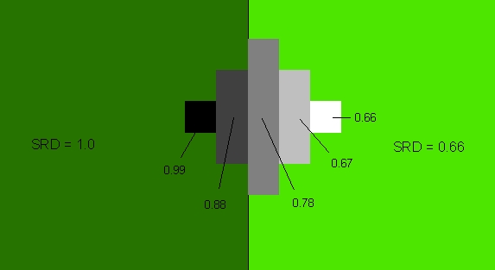

Result: NRD is based on a Gaussian formula, equal to the expected values calculated using MS Excel.

Note: For tests 32 through 34, NeighborRadius = 200

NRD values used for tests 32-34

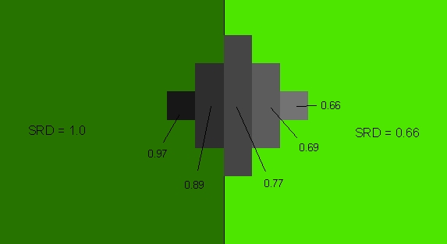

Test 32 – NeighborWeight equals 0.5

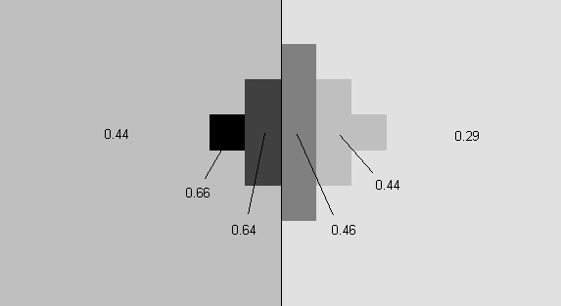

Result: values equal SV equation (referenced in test 27) using NW =0 .5 and ROS = 2.

Test 33 – NeighborWeight equals 2

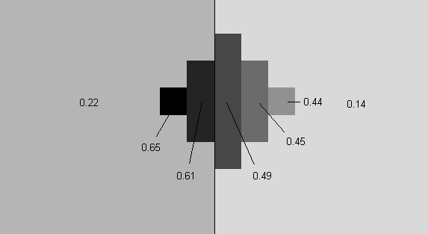

Result: Values equal SV equation (referenced in test 27) using NW =2 and ROS = 2.

Test 34 – NeighborWeight equals 10

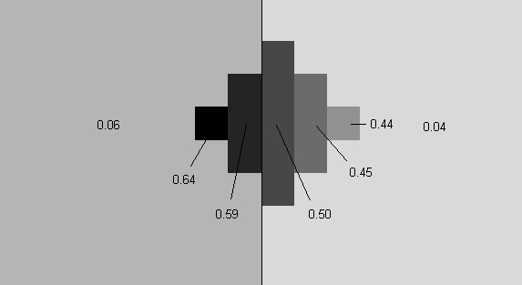

Result: Values equal SV equation (referenced in test 27) using NW =10 and ROS = 2.

Note: For tests 35 through 38, NeighborRadius = 1000

Test 35 – NeighborSpeedUp equals none

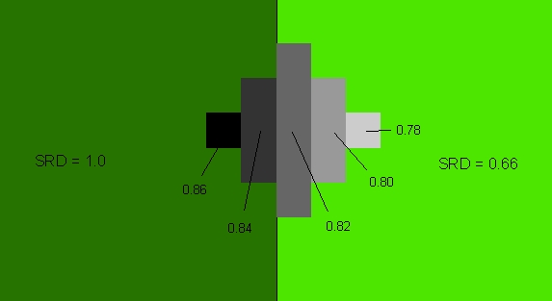

Test 36 – NeighborSpeedUp equals 2x

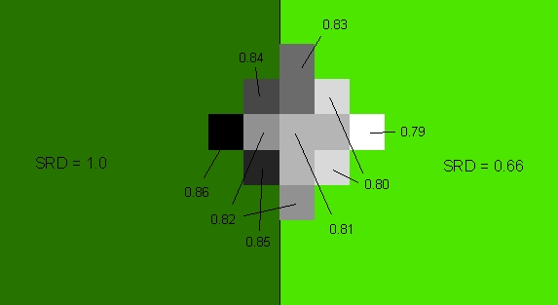

Result: The values are generally similar, although not exactly equal to the complete neighbor sample. Note: we would expect a closer match as neighborhood size increases.

Test 37 – NeighborSpeedUp equals 3x

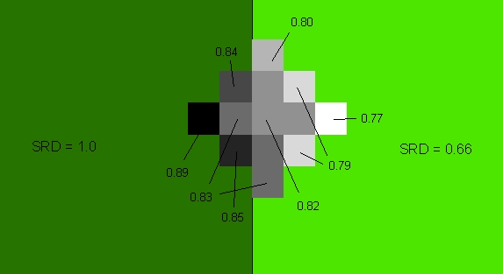

Result: The values are generally similar, although not exactly equal to the complete neighbor sample.

Test 38 – NeighborSpeedUp equals 4x

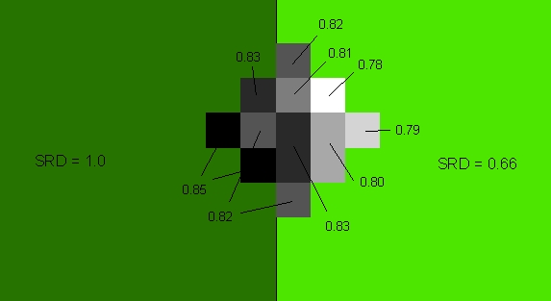

Result: The values are generally similar, although not exactly equal to the complete neighbor sample.

Tests 39 and 40 – Ecoregion Modifiers

Test 39 – EcoregionModifiers equals none
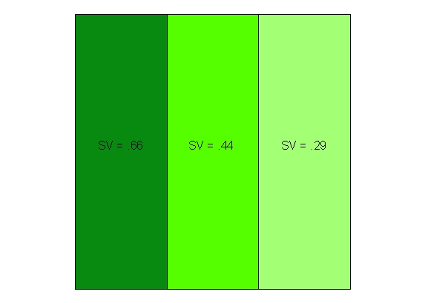

Test 40 – EcoregionModifiers equal -0.1(eco2), 0.1(eco3)
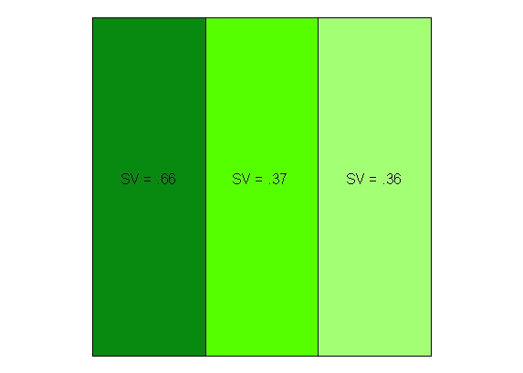

Result: As expected, Site Vulnerability (SV) in eco2 decreases while eco3’s SV increases

Test 41 – MinROS and MaxRos equal 2

Test 42 – MinROS and MaxROS equal 1

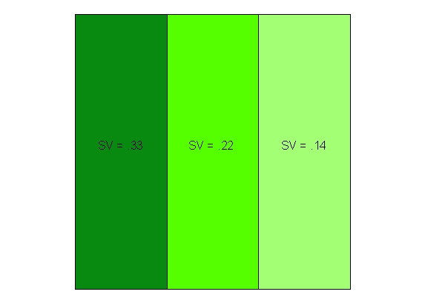
Result: SV values are halved, as expected.

Tests 43 through 50 – Regional Outbreak Inputs

Default Values

TemporalType = Pulse
RandomFunction = RFUniform
RandomParameter1 = 10
RandomParameter2 = 2
MinROS = 0
MaxROS = 3

Test43 – TemporalType equals Pulse

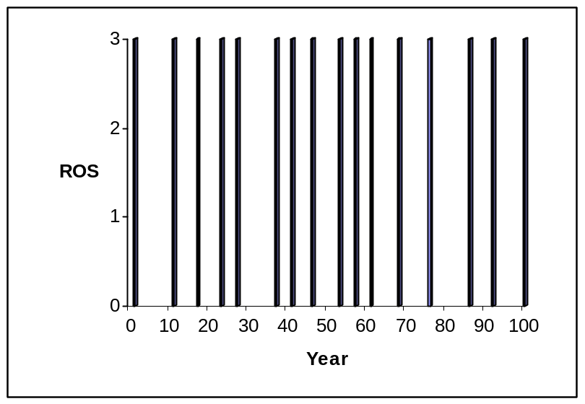

Result: With MinROS = 0 and MaxROS = 3, ROS will be either 0 (no outbreak) or 3.

Test44 – TemporalType equals VariablePulse

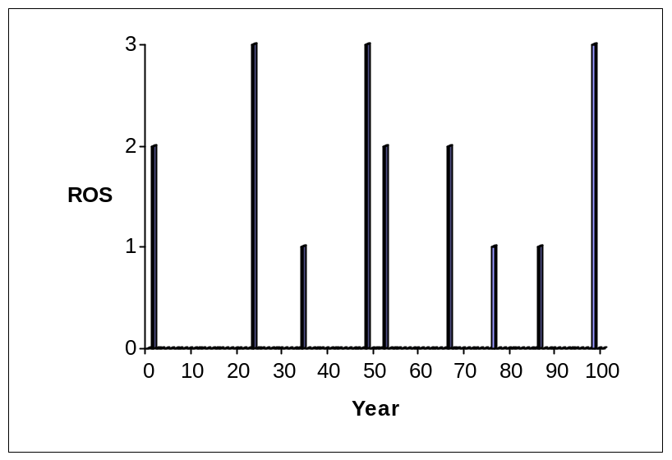

Result: With MinROS = 0 and MaxROS = 3, ROS will be either 0 (no outbreak) or in the range from MinROS+1 to 3.

Test 45 – RandomParameter1 equals 10

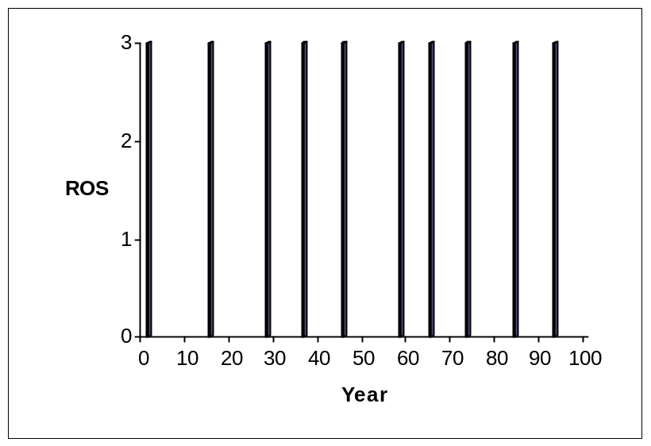

Result: Outbreaks occur approximately once every 10 years, as expected

Test 46 – RandomParameter1 equals 25

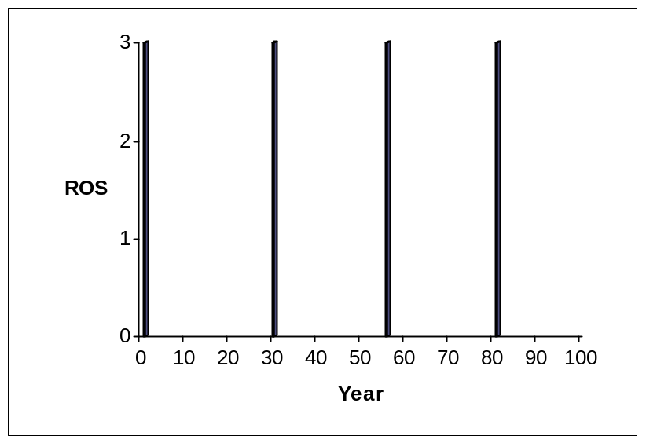

Result: Outbreaks occur approximately once every 25 years, as expected

Test 47 – RandomParameter2 equals 0

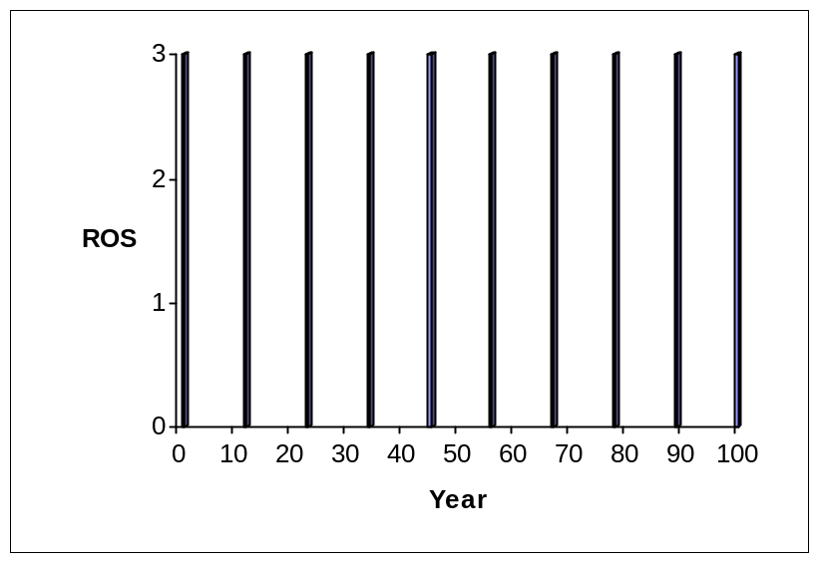

Result: Outbreak occurrence has no standard deviation, as expected.

Test 48 – RandomParameter2 equals 4

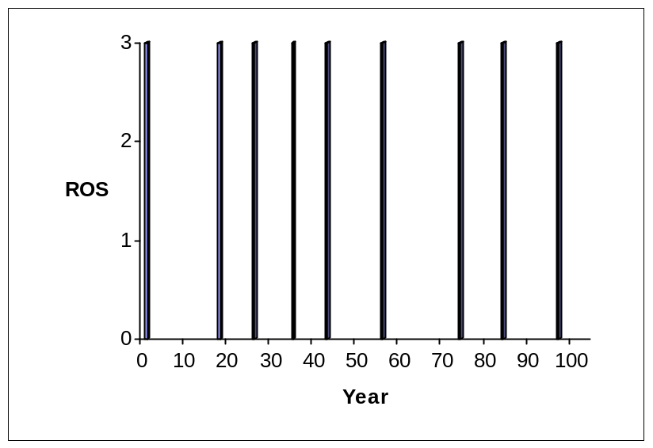

Result: Outbreak occurrence has standard deviation, as expected.

Test 49 – RandomFunction equals RFNormal

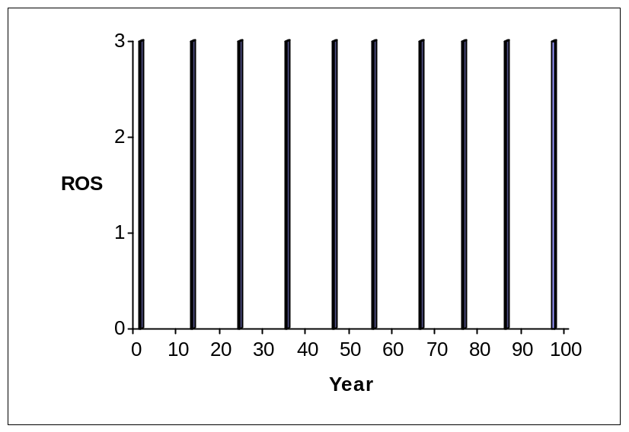

Result: Outbreaks occur at a normal distribution, where mean occurrence equals RandomParameter1 (10) and standard deviation equals RandomParameter2 (1).

Test 50 – RandomFunction equals RFUniform

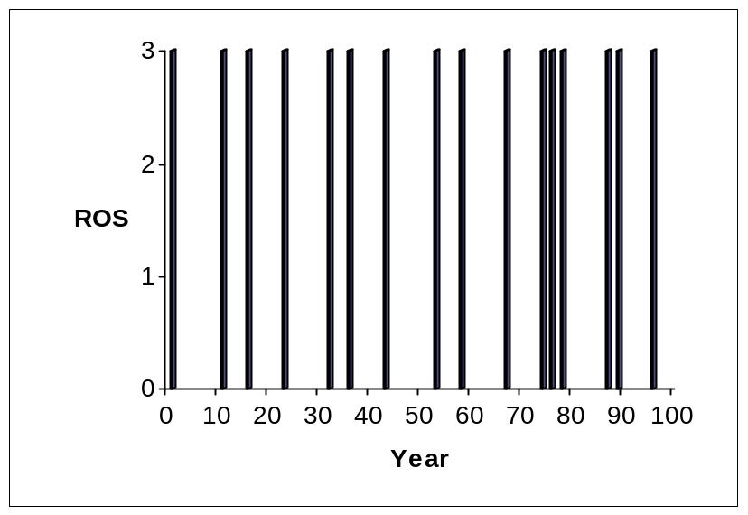

Result: Outbreaks occur at a uniform distribution, where outbreaks occur between RandomParameter1 (1) and RandomParameter2 (10) years apart.

